

**CAPSTONE PROJECT 2**

**DATABASE DESIGN DOCUMENT**

**WHAT SHOULD I EAT TODAY?**

**VERSION: 1.0**

**Mentor : Nguyen Thi Bao Trang**

**Project Team : 101dogS Team**

**Team Members : Le Nguyen Hoang Van**

**Luong Minh Hieu**

**Tran Quang Khai**

**Nguyen Dinh Luu**

**03/22/2020**

**INTERNATIONAL SCHOOL OF DUYTAN UNIVERSITY**

**Project Information**

|  |  |  |  |
| --- | --- | --- | --- |
| **Project Acronym** | WIET | | |
| **Project Title** | What should I eat today? | | |
| **Start Date** | 02/12/2020 | **End Date** | 05/15/2020 |
| **Lead Institution** | International School, Duy Tan University | | |
| **Project Mentor** | Nguyen Thi Bao Trang | | |
| **Product Owner & Contact Detail** | Le Nguyen Hoang Van | | |
| **Partner Organization** | TBD | | |
| **Scrum Master** | Le Nguyen Hoang Van | lenguyenhoangvan18@gmail.com | 0935604934 |
| **Team Members** | Luong Minh Hieu | minhhieu98@gmail.com | 0399870055 |
| Nguyen Dinh Luu | dinhluu098@gmail.com | 0935883503 |
| Tran Quang Khai | tquangkhai98@gmail.com | 0976308098 |

|  |  |  |  |
| --- | --- | --- | --- |
| **Document Details** | | | |
| **Document Title** | Database Design Document | | |
| **Author(s)** | 101dogS Team | | |
| **Role** | Product Owner, Team Member, Scrum Master | | |
| **Date** | 04/23/2020 | **File name:** | DatabaseDesign-Caps2-101dogS-ver1.0 |
| **URL** |  | | |
| **Access** | Project and CMU Program | | |

**Revision History**

|  |  |  |  |
| --- | --- | --- | --- |
| **Version** | **Person(s)** | **Date** | **Description** |
| **1.0** | Le Nguyen Hoang Van | 03/22/2020 | Draft document |

|  |  |  |  |
| --- | --- | --- | --- |
| **Document Approval**  The following signatures are required for approval of this document | | | |
| **Mentor** | Nguyen Thi Bao Trang | **Signature:** |  |
| **Date:** |  |
| **Product owner** | Le Nguyen Hoang Van | **Signature:** |  |
| **Date:** |  |
| **Scrum master** | Le Nguyen Hoang Van | **Signature:** |  |
| **Date:** |  |
| **Team member(s)** | Nguyen Dinh Luu | **Signature:** |  |
| **Date:** |  |
| Tran Quang Khai | **Signature:** |  |
| **Date:** |  |
| Luong Minh Hieu | **Signature:** |  |
| **Date:** |  |

Contents

1. Introduction 4

1.1. Purpose 4

1.2. Scope 5

1.3. Definitions, Acronyms and Abbreviations 5

2. Hardware and Software Requirement 6

3. Mapping Rules 6

4. Database Design 6

4.1. Table Overview 6

4.2. Table Relationship Diagram 8

4.3. Table Details 9

4.3.1. Tbl_store 9

4.3.2. Tbl_food 9

4.3.3. Food_tag 10

4.3.4. Mst_tag 10

4.3.5. Tag_meta_tag 10

4.3.6. Mst_meta_tag 10

4.3.7. Meta_tag_super_tag 10

4.3.8. Mst_super_tag 11

4.3.9. Tbl_city 11

4.3.10. Rating 11

4.3.11. Tbl_survey 11

4.3.12. Tbl_user 12

4.3.13. Tbl_fcm_token 12

4.3.14. Tbl_history 12

4.3.15. Tbl_allergy 13

4.3.16. Tbl_bookmark 13

4.3.17. Tbl_als_recommend 13

1. **Introduction**
   1. **Purpose**

* Setting up an overview about the database of WIET application
* Provides a database tables and the relationship between them
* Description designing a database (DB), a collection of data related to storage on a computer through database management system as a basis for data query related software.
* Provide the entire needed database for WIET application.
  1. **Scope**
* This Database Design Document provides the basic database design of Swimming Go application.
* It describes both logical and physical definition, non-functional, database interfaces, tables, code create table.
* It includes the tables and performance considerations and requirements. The following topics are covered in this document:
* Assumptions and decisions on database design
* Entity – mapping
* Table, column definitions
* Constraint: primary key, unique, foreign key.
* Column and row level validation rules (check constraints)
* Interfaces and dependencies with other components.
* This Database Design Document of WIET application is composed of definitions for database objects derived by mapping entities to tables, attributes to columns, unique identifiers to unique keys and relationship to foreign keys.
* During design, these initial definitions are enhanced to support the functionality described in the functional specification / user stories and defined in the primary and supporting modules of the application high level design.
  1. **Definitions, Acronyms and Abbreviations**

|  |  |  |
| --- | --- | --- |
| **Abbreviations** | **Description** | **Comment** |
| PK/FK | Primary/ Foreign Key | Use to indicate a file is a Primary or Foreign key in a table |
| ERD | Entity Relationship Diagram | Show the relationship between entities in the system |

1. **Hardware and Software Requirement**

This section provides an overview of the software and hardware architecture. The following describes the technology components of WIET application.

|  |  |
| --- | --- |
| **The technology component of WIET application** | |
| **Attribute** | **Description** |
| **Database** | PostgreSQL |
| **Software** |  |
| **Hardware** |  |

1. **Mapping Rules**

When mapping entities to tables, the following rules were applied:

* Entities are mapped into tables in a one to one manner.
* Attributes are mapped to columns in a one to one manner.
* One-to-many relationships are mapped to foreign keys.
* With link 1-1: set the primary key the one of two relations into relations other make foreign key.
* With link 1-n: set the primary key the one relation into many relations make foreign key.
* With link n-n: create sub table, then set primary key of 2 tables make foreign key of sub table.

1. **Database Design**
   1. **Table Overview**

|  |  |  |
| --- | --- | --- |
| **No** | **Table name** | **Short Description** |
| 1 | Tbl_store | Store’s information |
| 2 | Tbl_food | Food’s information |
| 3 | Food_tag | Sub food-tag table |
| 4 | Mst_tag | Tag’s information |
| 5 | Tag_meta_tag | Sub tag-meta_tag table |
| 6 | Mst_meta_tag | Meta tag’s information |
| 7 | Meta_tag_super_tag | Sub meta_tag-super_tag table |
| 8 | Mst_super_tag | Super tag’s information |
| 9 | Mst_city | City’s information |
| 10 | Rating | Sub rating table |
| 11 | Tbl_survey | Survey’s information |
| 12 | Tbl_user | User’s information |
| 13 | Tbl_fcm_token | FCM token’s information |
| 14 | Tbl_history | History’s information |
| 15 | Tbl_allergy | Allergy’s information |
| 16 | Tbl_bookmark | Bookmark’s information |
| 17 | Tbl_als_recommend | ALS rating’s information |

* 1. **Table Relationship Diagram**

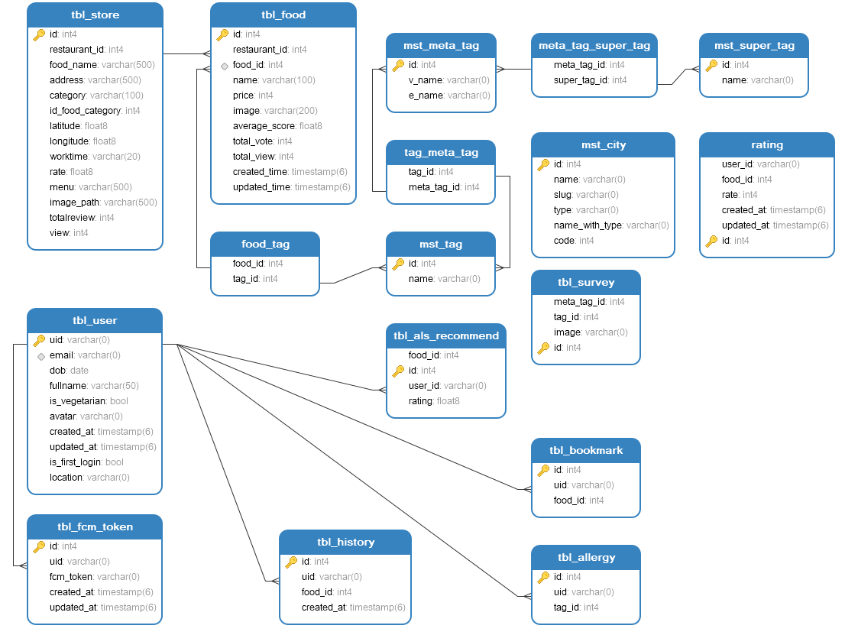

*Figure 1: Table relationship diagram*

* 1. **Table Details**
     1. **Tbl_store**

|  |  |  |  |  |  |
| --- | --- | --- | --- | --- | --- |
| **Attributes** | **Data Type** | **Key** | **Null** | **Default** | **Description** |
| Id | Int4 | PK | Not null | Auto increment |  |
| Restaurant_id | Int4 |  | Not null |  |  |
| Food_name | Varchar(500) |  | Not null |  |  |
| Address | Varchar(500) |  | Not null |  |  |
| Category | Varchar(100) |  | Not null |  |  |
| Id_food_category | Int4 |  |  |  |  |
| Latitude | Float8 |  | Not null |  |  |
| Longitude | Float8 |  | Not null |  |  |
| Worktime | Varchar(20) |  |  |  |  |
| Rate | Float8 |  |  |  |  |
| Menu | Varchar(500) |  | Not null |  |  |
| Image_path | Varchar(500) |  |  |  |  |
| Totalreview | Int4 |  | Not null | 0 |  |
| View | Int4 |  | Not null | 0 |  |

* + 1. **Tbl_food**

|  |  |  |  |  |  |
| --- | --- | --- | --- | --- | --- |
| **Attributes** | **Data Type** | **Key** | **Null** | **Default** | **Description** |
| Id | Int4 | PK | Not null | Auto increment |  |
| Restaurant_id | Int4 | FK | Not null |  |  |
| Food_id | Int4 |  | Not null |  |  |
| Name | Varchar(100) |  | Not null |  |  |
| Price | Int4 |  | Not null |  |  |
| Image | Varchar(200) |  | Not null |  |  |
| Average_score | Float8 |  |  | 0 |  |
| Total_vote | Int4 |  |  | 0 |  |
| Total_view | Int4 |  |  | 0 |  |
| Created_time | Timestamp(6) |  | Not null | Current timestamp |  |
| Updated_time | Timestamp(6) |  | Not null | Current timestamp |  |

* + 1. **Food_tag**

|  |  |  |  |  |  |
| --- | --- | --- | --- | --- | --- |
| **Attributes** | **Data Type** | **Key** | **Null** | **Default** | **Description** |
| Food_id | Int4 | FK | Not null |  |  |
| Tag_id | Int4 | FK | Not null |  |  |

* + 1. **Mst_tag**

|  |  |  |  |  |  |
| --- | --- | --- | --- | --- | --- |
| **Attributes** | **Data Type** | **Key** | **Null** | **Default** | **Description** |
| Id | Int4 | PK | Not null | Auto increment |  |
| Name | Varchar(0) |  | Not null |  |  |

* + 1. **Tag_meta_tag**

|  |  |  |  |  |  |
| --- | --- | --- | --- | --- | --- |
| **Attributes** | **Data Type** | **Key** | **Null** | **Default** | **Description** |
| Tag_id | Int4 | FK | Not null |  |  |
| Meta_tag_id | Int4 | FK | Not null |  |  |

* + 1. **Mst_meta_tag**

|  |  |  |  |  |  |
| --- | --- | --- | --- | --- | --- |
| **Attributes** | **Data Type** | **Key** | **Null** | **Default** | **Description** |
| Id | Int4 | PK | Not null | Auto increment |  |
| V_name | Varchar(0) |  | Not null |  |  |
| E_name | Varchar(0) |  | Not null |  |  |

* + 1. **Meta_tag_super_tag**

|  |  |  |  |  |  |
| --- | --- | --- | --- | --- | --- |
| **Attributes** | **Data Type** | **Key** | **Null** | **Default** | **Description** |
| Meta_tag_id | Int4 | FK | Not null |  |  |
| Meta_tag_id | Int4 | FK | Not null |  |  |

* + 1. **Mst_super_tag**

|  |  |  |  |  |  |
| --- | --- | --- | --- | --- | --- |
| **Attributes** | **Data Type** | **Key** | **Null** | **Default** | **Description** |
| Id | Int4 | PK | Not null | Auto increment |  |
| Name | Varchar(0) |  | Not null |  |  |

* + 1. **Tbl_city**

|  |  |  |  |  |  |
| --- | --- | --- | --- | --- | --- |
| **Attributes** | **Data Type** | **Key** | **Null** | **Default** | **Description** |
| Id | Int4 | PK | Not null | Auto increment |  |
| Name | Varchar(0) |  | Not null |  |  |
| Slug | Varchar(0) |  | Not null |  |  |
| Type | Varchar(0) |  | Not null |  |  |
| Name_with_type | Varchar(0) |  | Not null |  |  |
| Code | Int4 |  | Not null |  |  |

* + 1. **Rating**

|  |  |  |  |  |  |
| --- | --- | --- | --- | --- | --- |
| **Attributes** | **Data Type** | **Key** | **Null** | **Default** | **Description** |
| User_id | Varchar(0) |  | Not null |  |  |
| Food_id | Int4 |  | Not null |  |  |
| Rate | Int4 |  | Not null |  |  |
| Created_at | Timestamp(6) |  | Not null | Current timestamp |  |
| Updated_at | Timestamp(6) |  | Not null | Current timestamp |  |
| Id | Int4 | PK | Not null | Auto increment |  |

* + 1. **Tbl_survey**

|  |  |  |  |  |  |
| --- | --- | --- | --- | --- | --- |
| **Attributes** | **Data Type** | **Key** | **Null** | **Default** | **Description** |
| Meta_tag_id | Int4 |  | Not null |  |  |
| Tag_id | Int4 |  | Not null |  |  |
| Image | Varchar(0) |  | Not null |  |  |
| Id | Int4 |  | Not null | Auto increment |  |

* + 1. **Tbl_user**

|  |  |  |  |  |  |
| --- | --- | --- | --- | --- | --- |
| **Attributes** | **Data Type** | **Key** | **Null** | **Default** | **Description** |
| Uid | Varchar(0) | PK | Not null |  |  |
| Email | Varchar(0) |  | Not null |  |  |
| Dob | Date |  | Not null | 1990-01-01 |  |
| Fullname | Varchar(50) |  | Not null |  |  |
| Is_vegetarian | Bool |  | Not null | 0 |  |
| Avatar | Varchar(0) |  | Not null |  |  |
| Created_at | Timestamp(6) |  | Not null | Current timestamp |  |
| Updated_at | Timestamp(6) |  | Not null | Current timestamp |  |
| Is_first_login | Bool |  | Not null | 1 |  |
| Location | Varchar(0) |  |  | Đà Nẵng |  |

* + 1. **Tbl_fcm_token**

|  |  |  |  |  |  |
| --- | --- | --- | --- | --- | --- |
| **Attributes** | **Data Type** | **Key** | **Null** | **Default** | **Description** |
| Id | Int4 | PK | Not null | Auto increment |  |
| Uid | Varchar(0) | FK | Not null |  |  |
| Fcm_token | Varchar(0) |  | Not null |  |  |
| Created_at | Timestamp(6) |  | Not null | Current timestamp |  |
| Updated_at | Timestamp(6) |  | Not null | Current timestamp |  |

* + 1. **Tbl_history**

|  |  |  |  |  |  |
| --- | --- | --- | --- | --- | --- |
| **Attributes** | **Data Type** | **Key** | **Null** | **Default** | **Description** |
| Id | Int4 | PK | Not null | Auto increment |  |
| Uid | Varchar(0) | FK | Not null |  |  |
| Food_id | Int4 | FK | Not null |  |  |
| Created_at | Timestamp(6) |  | Not null | Current timestamp |  |

* + 1. **Tbl_allergy**

|  |  |  |  |  |  |
| --- | --- | --- | --- | --- | --- |
| **Attributes** | **Data Type** | **Key** | **Null** | **Default** | **Description** |
| Id | Int4 | PK | Not null | Auto increment |  |
| Uid | Varchar(0) | FK | Not null |  |  |
| Food_id | Int4 | FK | Not null |  |  |

* + 1. **Tbl_bookmark**

|  |  |  |  |  |  |
| --- | --- | --- | --- | --- | --- |
| **Attributes** | **Data Type** | **Key** | **Null** | **Default** | **Description** |
| Id | Int4 | PK | Not null |  |  |
| Uid | Varchar(0) | FK | Not null |  |  |
| Food_id | Int4 | FK | Not null |  |  |

* + 1. **Tbl_als_recommend**

|  |  |  |  |  |  |
| --- | --- | --- | --- | --- | --- |
| **Attributes** | **Data Type** | **Key** | **Null** | **Default** | **Description** |
| Food_id | Int4 | FK | Not null |  |  |
| Id | Int4 | PK | Not null | Auto increment |  |
| User_id | Varchar(0) | FK | Not null |  |  |
| Rating | Float8 |  | Not null |  |  |